1. Step 1
   1. Create Database Name will be(Ex. tsmgmt)
2. Step 2
   1. config/PDO.php file open
   2. Add Database Connection Detail

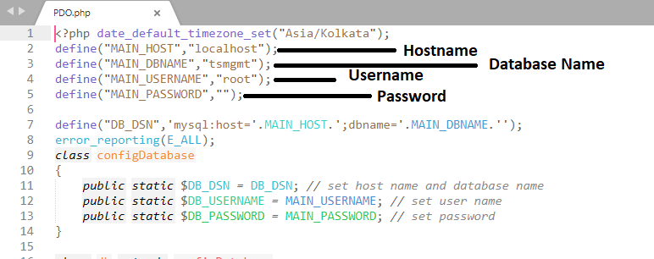

Run  
ex. http://localhost/tsmgmt/